Table of Contents

Purpose and Overview 2

Navigating the Report 2

Using Filters and Slicers 3

Interpreting Visualizations 3

Interactive Features 4

Export and Share 6

Actionable Insights 6

Data Provenance 6

Overview of Datasets 6

Cleansing and Validation 8

Hierarchy in Power BI 8

Measures calculated 9

Cleaned Dataset 10

# Purpose and Overview

This Power BI report is a comprehensive overview of Electric Vehicle Population data from Washington State Department of Licensing. This data is used to get insights and identify trends on Electric Vehicle Population in the Washington State to help them make decision on introducing their Electric Vehicle to new market. This power BI project only focuses on Washington State Electric Vehicle Population data.

The report address following key questions:

* How is the distribution of Electric Vehicles by state or county?
* How is the distribution of Electric Range among on Make, Models and Electric Vehicle Types?
* What is the trend of Electric Vehicle adoption over the years?

# Navigating the Report

The report is organized into four pages, each addressing a specific research question. Use the page tabs at the bottom to move seamlessly between the pages.

**Page 1**: Distribution of EVs by County by Model Year.

**Page 2**: Electric Range by Make/Model.

**Page 3**: Growth of Electric Vehicles Over Time.

**Page 4**: Top Counties with Highest EV Distribution.

When you hover over the button, tooltip will guide about next or previous page.

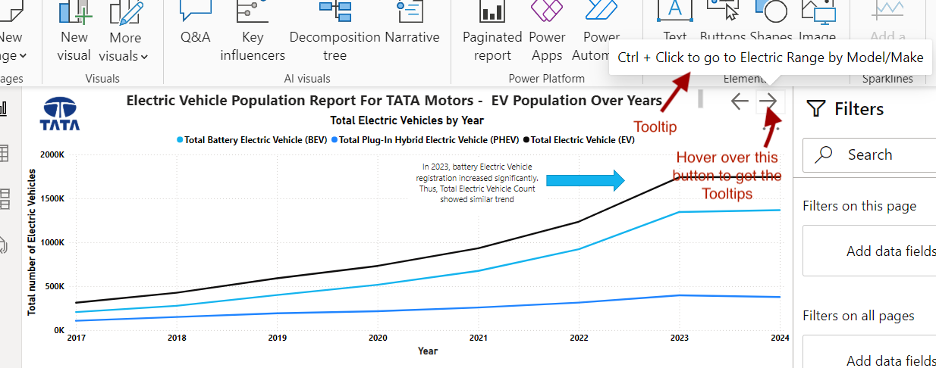

# Using Filters and Slicers

## Interpreting Visualizations

* **Maps** (Page 1): Observe geographic distribution of model year using animation.

* **Bar Chart** (Page 2): Use hierarchy data for county-City-level insights through drill up, drill down and Hierarchy.

* **Line Graph** (Page 3): Analyze the growth of EV types over the years to identify trends.
* **Tables** (Pages 2 and 3): Use detailed data for month-over-month growth and county-level insights.

* **Column Chart** (Page 4): Compare top-performing manufacturers and models based on electric range. We can drill down to various levels on Bar Chart to interpret the results

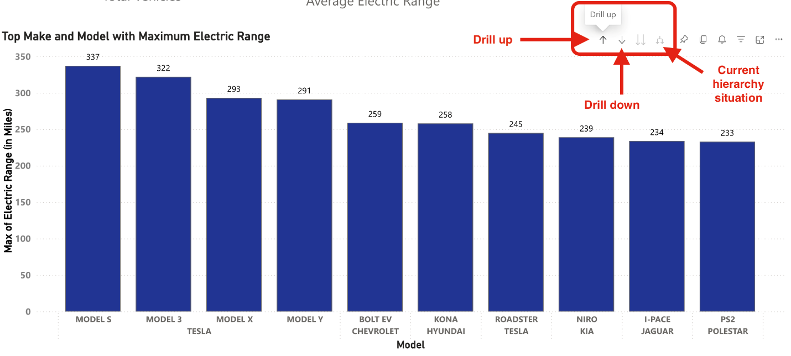

## Interactive Features

* Hover over bar chart graphs to display **tooltips** with additional data points, such as exact counts and maximum electric ranges. Tool tip is used to show Count of Vehicle in the figure below.

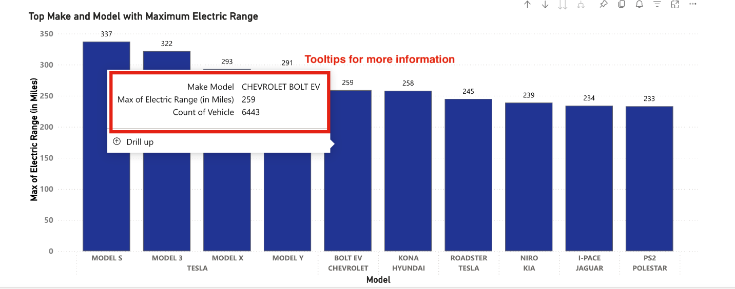

* **Slicers** are filters on a page used to show visualization about specific criteria.
  + **Vehicle Type Filter**: Toggle between BEVs and PHEVs to analyze specific trends or details.

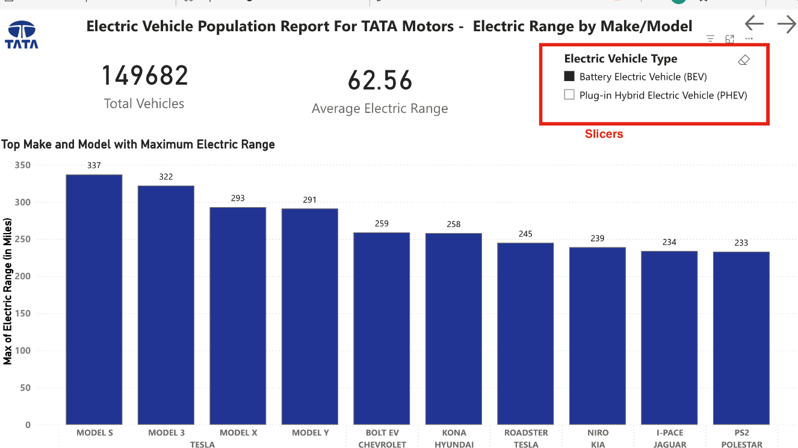

* **Drill down** in bar charts to explore hierarchical data (e.g., make and model or state and county)



# Export and Share

Export the report as a **PDF** or publish it on **Power BI service** to facilitate collaboration or presentation to stakeholders.

# Actionable Insights

**Market Entry Strategy**: Identify high-potential counties and cities (e.g., King County and Seattle).

**Competitor Analysis**: Focus on competitive benchmarks like Tesla’s leading electric range.

**Growth Trends**: Leverage BEV growth as a market entry point.

# Data Provenance

We have used two datasets (a. Electric Vehicle Population and b. Electric Vehicle Population History) for the data visualization. Both data were collected from the Washington State Department of Licensing (DOL).

## Overview of Datasets

1. **Electric Vehicle Population Dataset:** [Link to the Dataset](https://catalog.data.gov/dataset/electric-vehicle-population-data)

This data has 17 variables listed in the table below:

|  |  |  |  |
| --- | --- | --- | --- |
| **SN** | **Variables** | **Data Type** | **Description of Variables** |
| 1 | VIN (1-10) | Integer | The first 10 characters are the Vehicle Identification number. |
| 2 | County | Text | County of the vehicle owner address. |
| 3 | City | Text | City of the vehicle owner address. |
| 4 | State | Text | State of vehicle owner address. |
| 5 | Postal Code | Text | Zip code of the vehicle owner address. |
| 6 | Model Year | Year | Model year of the vehicle based on VIN (1999 to 2025) |
| 7 | Make | Text | Manufacturer of the vehicle based on VIN |
| 8 | Model | Text | Model name of the vehicle based on VIN |
| 9 | Electric Vehicle Type | Boolean | Describes if the vehicle is “Fully Electric” or “Plug-in Hybrid” |
| 10 | Clean Alternative Fuel Vehicle (CAFV) Eligibility | Text | Describes whether the EV is “Clean Alternative Fuel Vehicle Eligible”, “Not eligible due to low battery range” OR “Eligibility unknown as battery range has not been” |
| 11 | Electric Range | Number | Distance an EV can travel based on its electric charge. |
| 12 | Base MSRP | Number | Lowest retail price of EV suggested by Manufacturer not included due to insufficient data |
| 13 | Legislative District | Text | The Legislative District of Washington State is where vehicle owners live. |
| 14 | DOL Vehicle ID | Text | Unique number assigned by Department of Labor to the Vehicle |
| 15 | Vehicle Location | Point | GPS location for Vehicle |
| 16 | Electric Utility | Text | Electric power providers |
| 17 | 2020 Census Tract | Text | Redundant Geo-ID information |

All but “Vehicle Location”, “Electrical Utility” and “2020 Census Tract” variable data are collected/generated in the process of registration or renewing the vehicle at the department of Licensing. “Vehicle Location”, “Electrical Utility” and “2020 Census Tract” variable data are updated based on updated location of the data while taking census.

1. **Electric Vehicle Population History Dataset:** [Link to the Dataset](https://data.wa.gov/Transportation/Electric-Vehicle-Population-Size-History/d886-d5q2/about_data)

This dataset has 4 variables listed in the table below:

|  |  |  |
| --- | --- | --- |
| **Column Name** | **Datatype** | **Description** |
| Date | Date | Last day of the month |
| Plug-In Hybrid Electric Vehicle (PHEV) Count | Number | Count of Plugin Hybrid EV recorded by Washington Department of Licensing |
| Battery Electric Vehicle (BEV) Count | Number | Count of Battery EV recorded by Washington Department of Licensing |
| Electric Vehicle (EV) Total | Number | Total number of both types of vehicles |

This data is a count of the number of different kinds of vehicles which were recorded at the end of each month by Washington State Department of Licensing (DOL).

## Cleansing and Validation

1. **For Electric Vehicle Population Dataset:**

**Overview:**

|  |  |  |  |
| --- | --- | --- | --- |
| **Rows (Raw Dataset)** | 191,407 | **Column (Clean Dataset)** | 17 |
| **Rows Removed** | 29 | **Column Removed** | 5 |
| **Rows (Clean Dataset)** | 191,378 | **Column (Clean Dataset)** | 13 (Vehicle Location split to Longitude and Latitude) |

**Cleansing:**

* Five unnecessary variables were identified to be removed after analysis as they did not contribute to the goal of the project. Those were - VIN (1-10), Base MSRP, Legislative District, Electric Utility, and 2020 Census Tract.
* Vehicle Location variable was split into separate longitude and latitude columns for plotting into point maps.
* 4 rows with blank county values, 4 rows with missing longitude and latitude and 21 rows with incorrect postal code were removed to ensure data completeness and accuracy.

**Validation:**

* Model Year column was checked for valid years.
* Longitude and Latitude columns were validated between -180° to +180° and -90 to +90 respectively.
* Postal codes column was validated to be 5-digit numbers.
* State, City, County, Make, Model, Electric Vehicle Type, and Clean Alternative Fuel Vehicle (CAFV) Eligibility were checked to have appropriate and accurate value.

1. **For Electric Vehicle Population History Dataset:**

All the data in the new dataset was validated in Excel to have appropriate count. Data is not altered from the original dataset because all the data was consistent without any duplicates.

## Hierarchy in Power BI

1. For Electric Vehicle Population Dataset,two hierarchies were made to show information in the visualization.

* The first one is with State, County and City to avoid duplication of county and city names.  Additionally, it will also help in drill-down in the visualization.
* The second one is with Make and Model to make a visualization which can be drilled down to Make, Model and combined level to show maximum Electric range.

1. For Electric Vehicle Population History Dataset, Date Hierarchy was constructed.

## Measures calculated

Measures were calculated for Electric Vehicle Population History Dataset:

* **BEV Previous Month** – To calculate Previous Month Battery Electric Vehicle (BEV) count (will be used to calculate Month over Month BEV growth).
* **PHEV Previous Month** – To calculate Previous Month Plug-in Hybrid Electric Vehicle (PHEV) count (will be used to calculate Month over Month PHEV growth).
* **Total EV Previous Month** – To calculate Previous Month Total Electric count (will be used to calculate Month over Month Total Electric growth).
* **Month Over Month Growth BEV (MOM Growth BEV)** - (Current Month BEV Count– Previous Month BEV Count)/Previous Month BEV Count
* **Month Over Month Growth PHEV (MOM Growth PHEV)** - (Current Month PHEV Count– Previous Month PHEV Count)/Previous Month PHEV Count
* **Month Over Month Growth Total EV (MOM Growth Total EV)** - (Current Month Total EV Count– Previous Month Total EV Count)/Previous Month Total EV Count

|  |  |
| --- | --- |
| **Measures** | **Power BI DAX Formula** |
| BEV Previous Month | **BEV previous month** = CALCULATE(SUM('EV Population by Month'[Battery Electric Vehicle (BEV) Count]),PREVIOUSMONTH('EV Population by Month'[Date].[Date])) |
| PHEV Previous Month | **PHEV previous month** = CALCULATE(SUM('EV Population by Month'[Plug-In Hybrid Electric Vehicle (PHEV) Count]),PREVIOUSMONTH('EV Population by Month'[Date].[Date])) |
| Total EV Previous Month | **Total EV previous month** = CALCULATE(SUM('EV Population by Month'[Electric Vehicle (EV) Total]),PREVIOUSMONTH('EV Population by Month'[Date].[Date])) |
| MOM Growth BEV | **MOM Growth BEV** = DIVIDE(SUM('EV Population by Month'[Battery Electric Vehicle (BEV) Count])-[BEV previous month],[BEV previous month],0) |
| MOM Growth PHEV | **MOM Growth PHEV** = DIVIDE(SUM('EV Population by Month'[Plug-In Hybrid Electric Vehicle (PHEV) Count])-[PHEV previous month],[PHEV previous month],0) |
| MOM Growth Total EV | **MOM Growth Total EV** = DIVIDE(SUM('EV Population by Month'[Electric Vehicle (EV) Total])-[Total EV previous month],[Total EV previous month],0) |